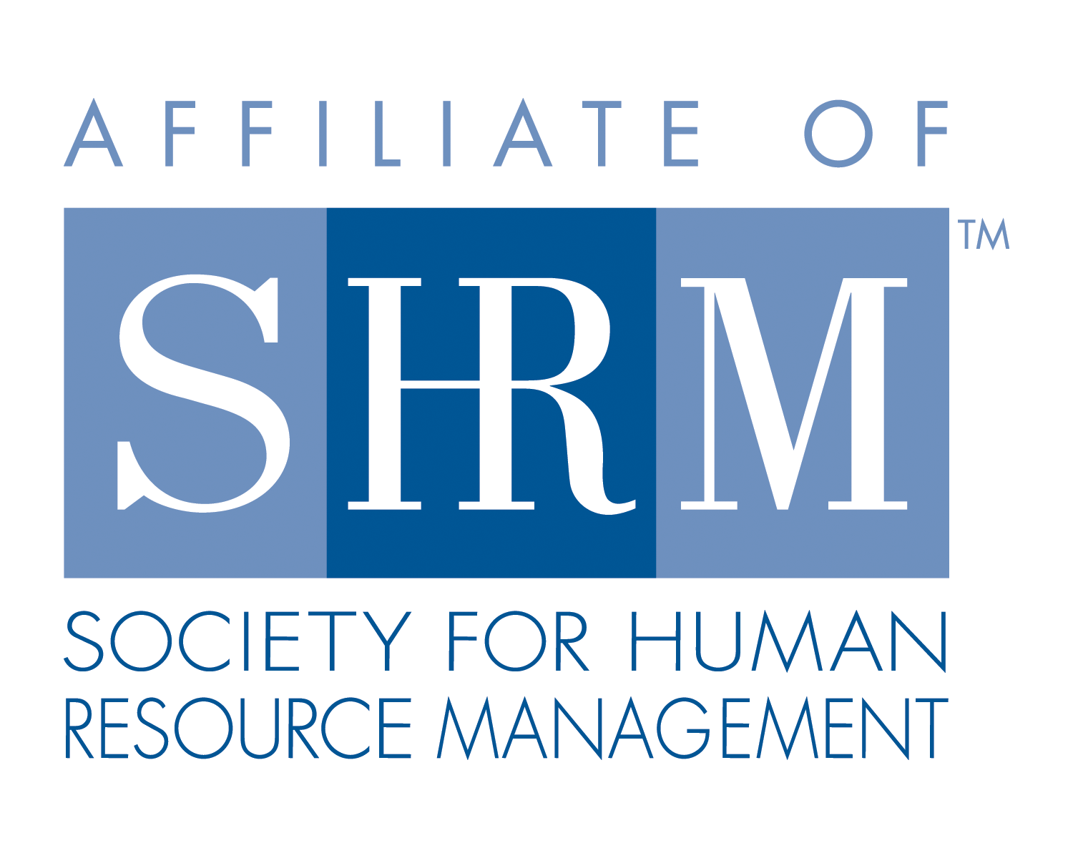


West Georgia SHRM Board Meeting
LaGrange College Cobb Board Room, LaGrange, GA
Tuesday, May 1, 2012

- Call to Order: 12:06 p.m. the SHRM Board meeting was called to order by Diana Goldwire.

Those present were: Diana Goldwire, Krystle Miller, Deborah Marchman, Frances Oubre, and Karen Redic, Kay Durand and Bobbie Leavins

- Minutes: approved as read

- Treasurer: The treasure’s report was given by Karen Redic. We currently have $10,702.03 in the account. All Approved.

- Chair Reports:

  - Membership: Kay Durand presented Joyce Leverette’s member applications to the board, the application was approved.

  - Education/College Relations/Certifications: No new business.

  - SHRM Foundation: No new business.

  - Legislative: No new business.

  - Workforce: No new business.

  - Communications: No new business.

  - Diversity: This position on the board remains open.

  - At Large: No new business.

- Old Business:
- If anyone has the sign in sheet from the Leadership Conference please contact Pamela.
- PHR Class

- New Business:

- No Board/General meetings in July
- Do our member companies want to donate to Donorchose.org? Proceeds go to subject specific projects headed by Troup County teachers.
- Book donations for Chloe Harrell’s book drive; books go to Mama Jama and her CLCP Summer Reading Program. We decided to announce to book drive at the May meeting and take up the donated books in June.
- Have a speaker come discuss the EEOC changes.
- Unemployment Workshop held at Kimberly Clark on May 17th; it is from 8:30am-12:00pm; cost is $25.00; 4 HRCI credits
- Troup Chamber of Commerce – Wage Survey – already completed.

- The meeting was adjourned at 12:36 p.m.

Respectfully Submitted,
Krystle Miller
West Georgia SHRM, Secretary

